Model Set Up II: Boundary Conditions and Initial Conditions

For hydrodynamic calcs, as well as temperature and constituent concentrations modeled by the AD equation, we need boundary conditions specified for every time step, as well as initial conditions at the beginning of the model run. We will go over where this information is specified.

1. Open up the ‘w2_con_DeGray4.5.xlsm’ file, open up the ‘W2manual45_Part3_InputOutputFiles_rev3.pdf’ file
2. **Hydrodynamic BCs:** Scroll to row 47 in the .xlsm, scroll to pdf page 34 in the W2manual
   1. The manual shows how different integer entries in this card ‘BRANCH GRID’ control how the model reads in boundary conditions for computing hydrodynamics (head or flow)
   2. In our case we see UHS = 0, DHS = 0 which means the model will expect to see an internal or external flow file, as opposed to a head boundary condition.
3. In W2manual, scroll to pdf page 267 to see where to define this file in the w2_con, 378 to see how these files should be formatted.
4. In the .xlsm, scroll to row 882
   1. We see in both the manual and the .xlsm that these inflow files should be specified for each branch. Note the file names given for QINFN (884) and QOTFN (887). Now go back into the file directory to check what these files look like, do they look like they should according to the W2manual?
5. **Hydrodynamic ICs:** See manual part 2 pdf page 35 – for lakes and reservoirs, velocity is typically zero and water surface elevation is set in the bathymetry file – we can check on that by opening bth1.csv

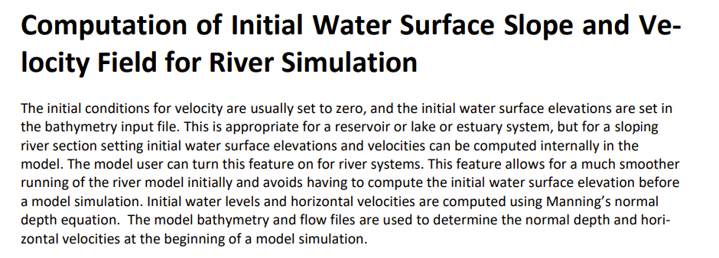

*From W2 User Manual Part 2 – Theory – PDF page 35*

1. **Temperature BCs (inflow):** The temperature boundary condition will be based on how the hydrodynamic BC is set up. If there’s a flow BC, there will be a temperature inflow file. If there’s a head BC, there will be an external temperature file for both upstream and downstream. We are not worried about the head boundaries nor the temperature files associated with those. Look at the row 885 to see what the temp inflow file is named. Look this up in the file directory to see what it looks like.
2. **Temperature ICs and downstream BC:** The temperature ICs can be defined 3 ways. Scroll to W2Manual part 3 pdf page 38. Scroll to row 65 in the .xlsm. We see that the initial temperature of -1 tells the model to read in another file, which initializes the temperature as a single vertical profile along every segment. Scroll down to row 875. Check the file name of this vertical profile and open the corresponding file from the file directory.
   1. The downstream temperature BC is based on these ICs. At every computation timestep, the downstream temperature BC is pulled from the previous timestep.
3. **Constituent Concentrations BCs (inflow):** The constituent concentration inflow BC is similar to the temp set up. See row 886 for the file name to check.
4. **Constituent Concentrations ICs and downstream BC:** Also a similar set up to how temp is initialized. See manual part 3 pdf page 159 for this description. In the .xlsm, scroll to row 401, column H, to see the initial conditions set for each active constituent. Notice that rows 427 and 428, representing algae and dissolved oxygen, are marked -1, so they are initialized as a vertical profile. As seen when inspecting the temperature ICs, the vertical profile file contains all this info together. The downstream BCs for constituents are determined in the same way as the temp DS BCs.
5. **Other inputs:** Flows, temperature, and concentrations can be impacted by other inputs, such as atmospheric deposition (row 874), distributed flows (row 888), and precipitation (row 891)
   1. Look at the file directory to see which of these files show up – we see corresponding files for atmospheric deposition and distributed flows. We can open them up to see what they look like. Atm dep is only a mass loading. It is not connected to a fluid flow. Distributed inflow, temp, and conc are connected.
   2. Scroll to .xlsm row 397 to view controls for the atmospheric deposition. What do these say?
   3. Scroll to .xlsm row 288 to view controls for the distributed flows, what does this say?
6. There are other inputs and outputs (accessory modules) but this is all we’ll cover for now. Most of these follow similar conventions.
7. Scroll to .xlsm, row 355 to create a second time series output for WQ constituents. Change cell C358 to 2, cell C362 to 28, C363 to 2, D362 to 28, D363 to 16. This is telling the model which cells to output the time series data for. We will use this to compare the effects of changing other parameters in the next case study.

Water Temperature Modeling Case Study: Check inputs and turn off all non-essential routines

1. **Checking met file:** Go to your file directory and open met.npt. You can check each of these time series against pdf page 350 of the W2 user manual part 3.
2. **Checking shade file:** Go to file directory and open shade.npt. You can check each of these time series against pdf page 369 of the W2 user manual part 3.
3. **Checking wind file:** Go to file directory and open wsc.npt. You can check this file against pdf page 360 of the W2 user manual part 3.
4. **Turn off all accessory functions:** Scroll to row 25 in the .xlsm and turn off all the accessory functions.
5. **Check HEAT EXCHANGE Card:** Scroll to row 90 in the .xlsm and check each parameter in the heat exchange card. Should be good to go. The wind height used is 10 m for this example and the coefficients in the wind function have been set to match that.
6. **Check temperature computation is turned on:** Scroll to row 295 in the .xlsm to check that temp computation is turned ON.
7. **Turn off water quality computations:** Scroll to row 395 in the .xlsm and turn OFF all other WQ computations.
8. **Delete other accessory modules from the file directory:** Check your “Index of Sheets” in the .xlsm against your file folder. Delete the files marked “presence or absence of file in model directory”
9. **Run Model**